Interfaces and Cables
CCNA study notes · Ethernet, UTP and fiber

1. Switch interfaces and RJ45
- A switch has many interfaces (also called ports), for example 24, so many end hosts such as PCs and servers can connect.
- The front of a switch is labelled something like 10/100/1000 BASE-T Port (1-24) and Ports are Auto-MDIX.
- These ports are RJ45 ports. RJ stands for registered jack. A computer on a wired network uses a port like this to connect.
- The RJ45 connector is used on the end of a copper Ethernet cable. Some Ethernet cables do not use copper wiring.

2. Ethernet, protocols and standards
- Ethernet is a collection of network protocols and standards.
- A network protocol is an agreed system of communicating, like a common language. Two people who speak different languages cannot communicate well without one.
- Hardware needs the same agreement. If the maker of the cable and the maker of the switch do not agree on the size and shape of the connector and port, you cannot connect them.
- That is why there are industry standards that all vendors follow, both physical (connectors, cables) and logical (such as IP).

Bits and bytes
- A bit is a value of either 0 or 1. Computers only understand 0s and 1s.
- A byte is a combination of 8 bits.
- Speed is measured in bits per second, not bytes per second, because each bit is sent one at a time.

Unit | Abbreviation | Bits
1 kilobit | Kb | 1,000
1 megabit | Mb | 1,000,000
1 gigabit | Gb | 1,000,000,000

3. Ethernet standards
Ethernet is defined in the IEEE 802.3 standard, first published in 1983. IEEE stands for Institute of Electrical and Electronics Engineers.
Speed | Common name | IEEE standard | Informal name | Max length
10 Mbps | Ethernet | 802.3i | 10BASE-T | 100 m
100 Mbps | Fast Ethernet | 802.3u | 100BASE-T | 100 m
1 Gbps | Gigabit Ethernet | 802.3ab | 1000BASE-T | 100 m
10 Gbps | 10 Gig Ethernet | 802.3an | 10GBASE-T | 100 m

- BASE refers to baseband signaling.
- T stands for twisted pair cabling.
- All of them have a maximum length of 100 meters. This is the maximum for twisted pair cable as defined in Ethernet, for performance and technical reasons.

4. UTP cabling
- The copper cables used in Ethernet are UTP cables, which stands for unshielded twisted pair.
- Unshielded means the wires have no metallic shield, which can make them vulnerable to electrical interference.
- Twisted means the wires are twisted together in pairs. The twisting helps protect against electromagnetic interference (EMI).
- A UTP cable has four pairs, so 8 wires in total.

Standard | Pairs used | Also known as
10BASE-T and 100BASE-T | 2 pairs (4 wires) | Ethernet and Fast Ethernet
1000BASE-T and 10GBASE-T | 4 pairs (8 wires) | Gigabit and 10 Gig Ethernet

5. Pin functions in 10BASE-T and 100BASE-T
Take a PC connected to a switch with a Fast Ethernet connection.
- The first pair is at pins 1 and 2, connecting to pins 1 and 2 on the switch. In a real UTP cable these two wires are twisted together, even though diagrams draw them straight.
- The PC transmits (TX) on pins 1 and 2. The switch cannot transmit on those pins, so it receives (RX) on pins 1 and 2.
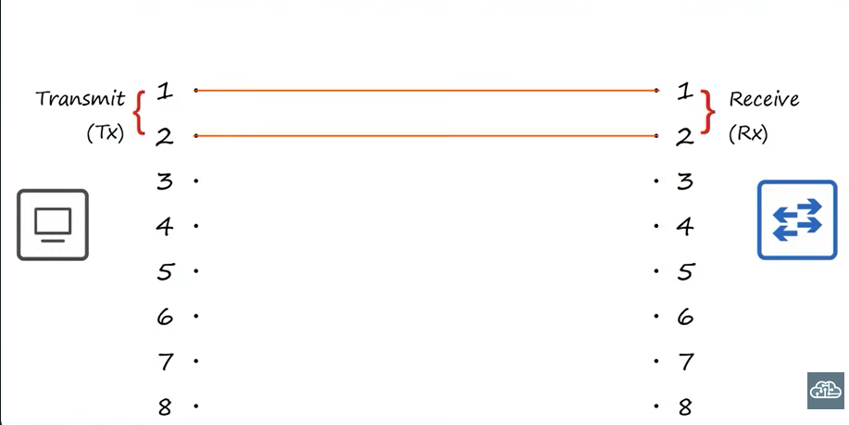
Figure 1: the PC transmits on pins 1 and 2 and the switch receives on them
Key rule
The network interface card on a PC or server transmits on pins 1 and 2, and the interface on a switch receives on pins 1 and 2.

- The second pair used in 10BASE-T and 100BASE-T is not 3 and 4, but pins 3 and 6.
- The functions are the opposite of pins 1 and 2: on the switch, pins 3 and 6 transmit, and on the PC, pins 3 and 6 receive.
- This allows full duplex transmission: both devices send and receive at the same time, with no collisions, because they use separate wires to transmit and receive.
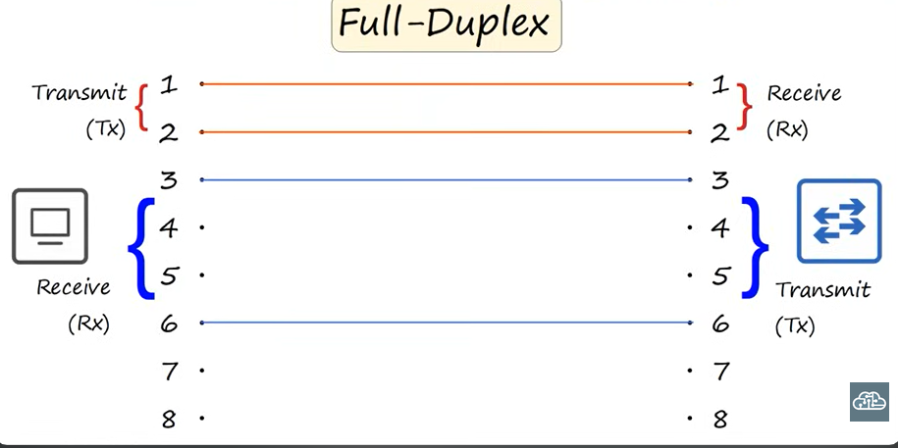
Figure 2: full duplex, with a separate pair for each direction
- Change the device on the left from a PC to a router and it is the same: the router transmits on pins 1 and 2 and receives on pins 3 and 6.
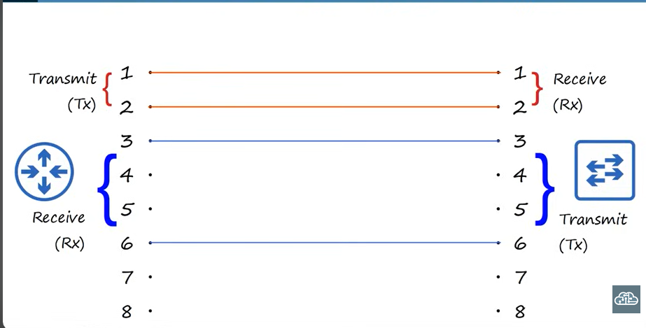
Figure 3: a router connected to a switch

6. Straight-through and crossover cables

Straight-through cable
- A copper Ethernet cable has an RJ45 connector at each end.
- In a straight-through cable, pin 1 on one end connects straight to pin 1 on the other, pin 2 to pin 2, pin 3 to pin 3, and so on.
- It works for PC to switch or switch to router, because one side transmits on 1 and 2 and the other receives on 1 and 2.

When straight-through does not work
- Replace the switch with another router. Both routers transmit on pins 1 and 2 and receive on pins 3 and 6, so the right router is not ready to receive on pins 1 and 2. Communication does not happen.
- The same applies to switch to switch, PC to PC, and a PC directly to a router, because both devices use the same pins to transmit.

Crossover cable
- In a crossover cable, the pins at one end do not connect to the same pins at the other end. The pairs are reversed.
- Pin 1 on one side connects to pin 3 on the other, and pin 2 connects to pin 6. Pin 3 connects to pin 1 and pin 6 connects to pin 2.
- The wires cross over each other, hence the name. The transmit pins on one side connect to the receive pins on the other, so the two devices can send data to each other.
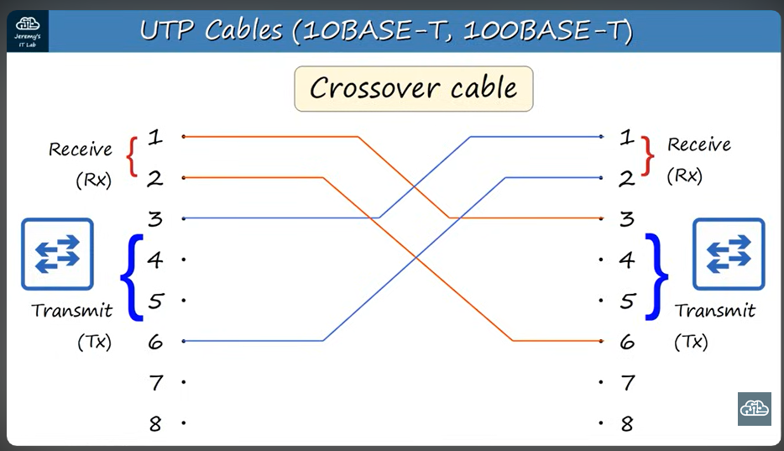
Figure 4: a crossover cable reverses the pairs

Device type | Transmit (TX) pins | Receive (RX) pins
Router | 1 and 2 | 3 and 6
Firewall | 1 and 2 | 3 and 6
PC | 1 and 2 | 3 and 6
Switch | 3 and 6 | 1 and 2

Key rule
Different device types (PC/router/firewall to switch): use a straight-through cable.
Same device types (switch to switch, router to router, PC to PC, PC to router): use a crossover cable.

7. Auto MDI-X
- Today you can use almost any cable to connect devices, because newer devices have a feature called Auto MDI-X.
- Previously, two switches connected with a straight-through cable could not communicate.
- Auto MDI-X lets a device detect which pins its neighbour is transmitting on and adjust which pins it uses to transmit and receive, so the devices can exchange data.
- Unless you work with quite old equipment, you do not need to worry about straight-through vs crossover. It is still good to know and to understand the concept.

8. Gigabit and faster copper Ethernet
- 1 Gigabit and 10 Gigabit Ethernet use all 8 wires.
- The extra two pairs are on pins 4 and 5 and pins 7 and 8.

9. Fiber optic cabling and SFP
- Copper UTP can be used for up to 100 meters. That is usually enough for a LAN, but not for larger networks.
- Fiber optic cable is a newer technology that is superior in many ways, such as distance.

SFP transceiver
- An SFP (small form-factor pluggable) transceiver is inserted into a device. A fiber optic cable then connects to it.
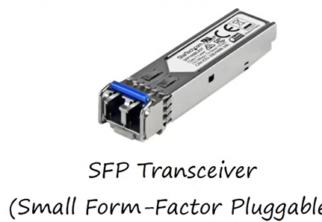
Figure 5: an SFP transceiver

Fiber optic cable
- Instead of electrical signals over copper, fiber optic cables send light over glass fibers.
- There are two connectors at each end: one to transmit and one to receive.
- Copper UTP uses separate wire pairs inside one cable to transmit and receive. Fiber uses separate cables: transmit on the left connects to receive on the right.
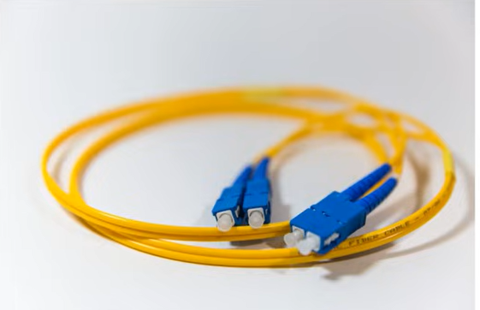
Figure 6: a fiber optic cable with two connectors per end
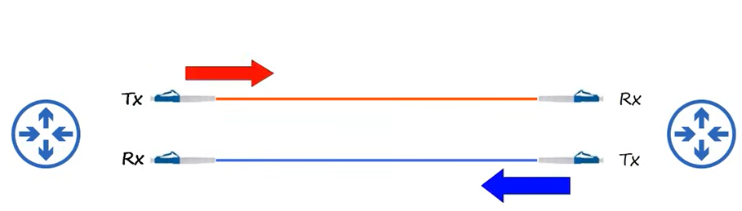
Figure 7: transmit on one side connects to receive on the other

Parts of a fiber optic cable
- The fiberglass core itself
- The cladding, which reflects light
- A protective buffer
- The outer jacket of the cable

Types of fiber
 | Single-mode fiber | Multimode fiber
Light paths | One path | Many paths
Distance | Very long distance | Shorter distance
Core | Very small | Larger
Cost | More expensive | Cheaper
Common use | Long distance, ISP, WAN | Buildings, LAN, data centers

10. UTP vs fiber optic cabling
 | UTP | Fiber optic
Cost | Lower | Higher
Maximum distance | Shorter (about 100 m) | Longer
EMI | Can be vulnerable | Not vulnerable
Ports | RJ-45 ports are cheaper | SFP ports are more expensive (single-mode costs more than multimode)
Signal leakage | Emits a faint signal outside the cable that can be copied (security risk) | Does not emit any signal outside the cable (no security risk)

CCNA tip
UTP = cheaper, about 100 m, vulnerable to EMI and eavesdropping. Fiber = more expensive, longer distance, immune to EMI, no signal leakage.

